**SIR SYED UNIVERSITY OF ENGINEERING & TECHNOLOGY**

**INFORMATION TECHNOLOGY DEPARTMENT**

**Spring 2022**

**System & Network Administration (IT-308)**

**Lab-Quiz**

Semester: V Batch: 2020s

Max Marks: 5

**INSTRUCTIONS**

# Provide your topology diagram with your name and IP addresses labelled on it

# Set unique hostname of router and switches including your name in the hostname

* Provide the screenshot of the following:
* Run “show running-configuration” on Router 0 and Router 1
* Submit your assignment in word or pdf format with your name and roll n.o mentioned
* Assignment should be submitted on email to tehmeed@ssuet.edu.pk

**TOPOLOGY:**

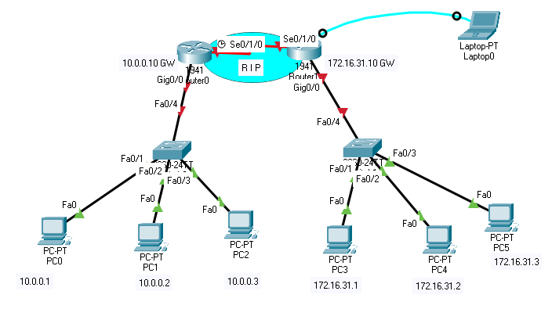

**1)** Design the following topology and assign the IP addresses according to the topology. Assign your own suitable IPs for pt-pt WAN link **(1pts)**

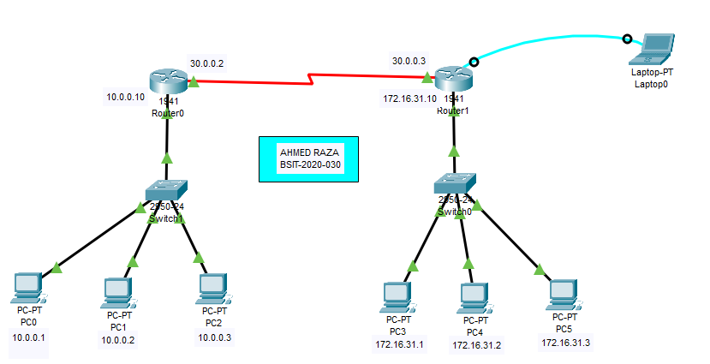

**2)** Use RIP as the routing protocol to create connectivity between the network devices. Ping

PC 4 from PC1, type “ show ip route” on Router 1 and attach both the screenshots. **(1pts)**

**3)** Console into Router 1 from the Terminal on Laptop 0, configure the hostname as router-(your name), Configure IP addressing on Router 1, Configure SSH on Router 1 and save the configuration to NVRAM. (**1 pts)**

**4)** SSH into Router 1 from PC 2 and attach the screenshot of the command prompt. (**1 pts)**

**5)** What is the difference between enable password and enable secret? What is the port n.o of

SSH (**1 pts)**